**Assignment 4 - 2D Arrays**

💡 **Question 1** Given three integer arrays arr1, arr2 and arr3 **sorted** in **strictly increasing** order, return a sorted array of **only** the integers that appeared in **all** three arrays.

**Example 1:**

Input: arr1 = [1,2,3,4,5], arr2 = [1,2,5,7,9], arr3 = [1,3,4,5,8]

Output: [1,5]

**Explanation:** Only 1 and 5 appeared in the three arrays.

***Solution -***

arr1 = [1, 2, 3, 4, 5]

arr2 = [1, 2, 5, 7, 9]

arr3 = [1, 3, 4, 5, 8]

def find_common_elements(arr1, arr2, arr3):

    set1 = set(arr1)

    set2 = set(arr2)

    set3 = set(arr3)

    # Find the intersection of the three sets

    common_elements = set1.intersection(set2, set3)

    # Convert the set back to a sorted list

    result = sorted(list(common_elements))

    return result

result = find_common_elements(arr1, arr2, arr3)

print(result)

💡 **Question 2**

Given two **0-indexed** integer arrays nums1 and nums2, return *a list* answer *of size* 2 *where:*

* answer[0] *is a list of all* ***distinct*** *integers in* nums1 *which are* ***not*** *present in* nums2*.*
* answer[1] *is a list of all* ***distinct*** *integers in* nums2 *which are* ***not*** *present in* nums1.

**Note** that the integers in the lists may be returned in **any** order.

**Example 1:**

**Input:** nums1 = [1,2,3], nums2 = [2,4,6]

**Output:** [[1,3],[4,6]]

**Explanation:**

For nums1, nums1[1] = 2 is present at index 0 of nums2, whereas nums1[0] = 1 and nums1[2] = 3 are not present in nums2. Therefore, answer[0] = [1,3].

For nums2, nums2[0] = 2 is present at index 1 of nums1, whereas nums2[1] = 4 and nums2[2] = 6 are not present in nums2. Therefore, answer[1] = [4,6].

***Solution -***

nums1 = [1, 2, 3]

nums2 = [2, 4, 6]

def find_disjoint_elements(nums1, nums2):

    distinct_nums1 = []

    distinct_nums2 = []

    for num in nums1:

        if num not in nums2:

            distinct_nums1.append(num)

    for num in nums2:

        if num not in nums1:

            distinct_nums2.append(num)

    return [distinct_nums1, distinct_nums2]

result = find_disjoint_elements(nums1, nums2)

print(result)

💡 **Question 3** Given a 2D integer array matrix, return the ***transpose*** of matrix.

The **transpose** of a matrix is the matrix flipped over its main diagonal, switching the matrix's row and column indices.

**Example 1:**

Input: matrix = [[1,2,3],[4,5,6],[7,8,9]]

Output: [[1,4,7],[2,5,8],[3,6,9]]

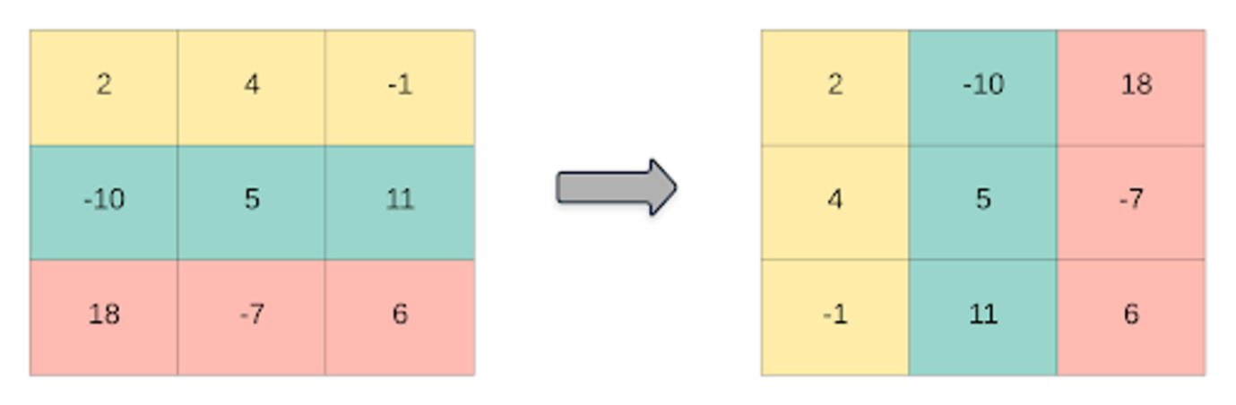

***Solution -***

def transpose(matrix):

    rows = len(matrix)

    cols = len(matrix[0])

    # Create a new matrix with dimensions switched

    transposed = [[0 for _ in range(rows)] for _ in range(cols)]

    for i in range(rows):

        for j in range(cols):

            transposed[j][i] = matrix[i][j]

    return transposed

matrix = [[1, 2, 3], [4, 5, 6], [7, 8, 9]]

result = transpose(matrix)

print(result)

💡 **Question 4** Given an integer array nums of 2n integers, group these integers into n pairs (a1, b1), (a2, b2), ..., (an, bn) such that the sum of min(ai, bi) for all i is **maximized**. Return the maximized sum.

**Example 1:**

Input: nums = [1,4,3,2]

Output: 4

**Explanation:** All possible pairings (ignoring the ordering of elements) are:

1. (1, 4), (2, 3) -> min(1, 4) + min(2, 3) = 1 + 2 = 3
2. (1, 3), (2, 4) -> min(1, 3) + min(2, 4) = 1 + 2 = 3
3. (1, 2), (3, 4) -> min(1, 2) + min(3, 4) = 1 + 3 = 4

So the maximum possible sum is 4.

***Solution –***

def array_pair_sum(nums):

    nums.sort()  # Sort the array in ascending order

    max_sum = 0

    for i in range(0, len(nums), 2):

        max_sum += nums[i]

    return max_sum

nums = [1, 4, 3, 2]

result = array_pair_sum(nums)

print(result)

💡 **Question 5** You have n coins and you want to build a staircase with these coins. The staircase consists of k rows where the ith row has exactly i coins. The last row of the staircase **may be** incomplete.

Given the integer n, return the number of ***complete rows*** of the staircase you will build.

**Example 1:**



**Input:** n = 5

**Output:** 2

**Explanation:** Because the 3rd row is incomplete, we return 2.

***Solution –***

import math

n = 5

def arrange_coins(n):

    k = int(math.sqrt(2 * n))

    # Check if the sum of the first k natural numbers is greater than n

    if k * (k + 1) > 2 * n:

        return k - 1

    else:

        return k

result = arrange_coins(n)

print(result)

💡 **Question 6** Given an integer array nums sorted in **non-decreasing** order, return an array of ***the squares of each number*** sorted in non-decreasing order.

**Example 1:**

Input: nums = [-4,-1,0,3,10]

Output: [0,1,9,16,100]

**Explanation:** After squaring, the array becomes [16,1,0,9,100]. After sorting, it becomes [0,1,9,16,100]

***Solution -***

def sorted_squares(nums):

    # Square each number in the array

    squared = [num ** 2 for num in nums]

    # Sort the squared array in non-decreasing order

    squared.sort()

    return squared

nums = [-4, -1, 0, 3, 10]

result = sorted_squares(nums)

print(result)

💡 **Question 7** You are given an m x n matrix M initialized with all 0's and an array of operations ops, where ops[i] = [ai, bi] means M[x][y] should be incremented by one for all 0 <= x < ai and 0 <= y < bi.

Count and return the number of maximum integers in the matrix after performing all the operations

**Example 1:**

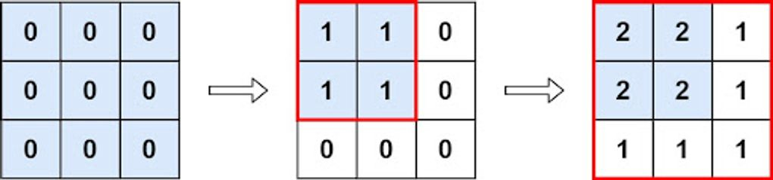

**Input:** m = 3, n = 3, ops = [[2,2],[3,3]]

**Output:** 4

**Explanation:** The maximum integer in M is 2, and there are four of it in M. So return 4.

***Solution -***

def max_count(m, n, ops):

    min_a = m

    min_b = n

    for op in ops:

        min_a = min(min_a, op[0])

        min_b = min(min_b, op[1])

    return min_a * min_b

m = 3

n = 3

ops = [[2, 2], [3, 3]]

result = max_count(m, n, ops)

print(result)

💡 **Question 8**

Given the array nums consisting of 2n elements in the form [x1,x2,...,xn,y1,y2,...,yn].

Return the array in the form [x1,y1,x2,y2,...,xn,yn].

**Example 1:**

**Input:** nums = [2,5,1,3,4,7], n = 3

**Output:** [2,3,5,4,1,7]

**Explanation:** Since x1=2, x2=5, x3=1, y1=3, y2=4, y3=7 then the answer is [2,3,5,4,1,7].

***Solution –***

def shuffle(nums, n):

    result = []

    for i in range(n):

        result.append(nums[i])

        result.append(nums[i + n])

    return result

nums = [2, 5, 1, 3, 4, 7]

n = 3

result = shuffle(nums, n)

print(result)